<https://workforcenow.adp.com/jobs/apply/posting.html?client=EastPenn&jobId=69798&lang=en_CA>

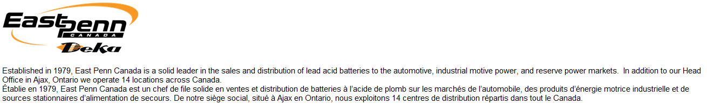

Top of Form

Bottom of Form

Top of Form

|  |  |  |  |  |  |  |  |  |
| --- | --- | --- | --- | --- | --- | --- | --- | --- |
| Search Jobs | | | English (Canada) |  |  |  |  |  | Help     |     Log In/Create A Profile |

Bottom of Form

**Project Manager, SAP Implementation Contract-Ajax**

East Penn Canada sells lead acid batteries to the automotive, industrial motive power and reserve power supply markets.  Through our Head Office located in Ajax, Ontario, we operate 15 distribution locations across Canada.   The Company is about to embark on a journey to implement SAP ECC 6.0 Business All in One for Distribution.  As a result, we have the following exciting opportunity currently available:

**Project Manager, SAP Implementation (12 month contract)**

The Project Manager will be responsible for the SAP Implementation project as well as a number of supporting projects of varying size and complexity relating to the IT infrastructure and systems.   The Project Manager’s primary role will be to develop project plans that are delivered within the agreed tolerances of time and budget.  Working in partnership with the different business and technical stakeholders, he/she will also be responsible for the coordination of multi-disciplinary project teams, tactical management, administration, and leadership throughout the project teams

**Duties & Responsibilities**

* Participates in all phases of the SAP implementation including blueprint/design, data conversion, quality assurance testing, user acceptance testing, training and support during and post go live
* Develops and maintains project plans, supporting documentation, reports, presentations and spreadsheets
* Organizes and coordinates project meeting schedules; records project meeting minutes
* Monitor the progress of the projects including budget and timelines, and make adjustments as necessary to ensure successful completion
* Creates and maintains schedules for all project related activities, including communications, testing and training
* Prepares and manages open item lists (issues, risks, changes, etc…)
* Provides direction to team activities and facilitates information validation and team decision-making process
* Evaluates project outcomes and prepares project closure documentation, including lessons learned

**Education / Certification**

* PMP Certification or equivalent
* Preferred: SAP Certified Associate Project Manager

**Experience, Skills & Competencies**

* Minimum of 10 years of project management experience, with a focus on IT projects
* Minimum of 5 years of experience working with SAP, and at least 2 SAP implementation cycles
* Strong working knowledge of MS office applications, including Word, Excel, PowerPoint, etc…
* Self-driven, able to work independently
* Excellent logical and analytical skills, requirements gathering and analysis
* Good verbal and written communication skills (English)
* Ability to work independently and in a team
* Respect for quality and deadlines
* Ability to liaise effectively with internal and external customers
* Provides excellent customer service
* Demonstrates operational excellence – Continually looks for new and better ways to get things done and shows functional/technical proficiency in work
* Exercises independent judgment within generally defined policies and practices to identify and select a solution
* Applies developed subject matter knowledge to solve common and complex business issues within established guidelines and recommends appropriate alternatives

**This opportunity WON’T last long, so apply TODAY!**

East Penn Canada is an equal opportunity employer and welcomes all qualified applicants to apply; accommodations will be made for people with disabilities.

To find out more information about our company and other positions available please go to our website at [www.EastPennCanada.com.](http://www.eastpenncanada.com/)